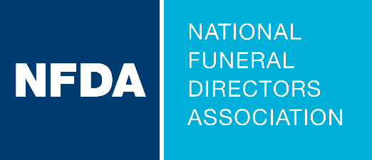

Event Justification Toolkit
Getting the Support to Participate in an NFDA Conference or Funeral Service Education Event

EVENT JUSTIFICATION TOOLKIT
NFDA has created a toolkit designed to provide you with the resources and strategies to secure your firm’s approval and financial support to attend a funeral service education event. By following the steps and using the included templates, you can effectively demonstrate the value of your attendance for both professional development and organizational benefit.

Contents of the Toolkit
- Templated Letter: A professional and persuasive letter template to formally request approval to attend the event. This letter emphasizes the benefits of the event and how it aligns with your company’s goals.
- Expense Worksheet: A detailed worksheet to outline the anticipated costs of attending the event, including registration fees, travel, lodging and meals. This document ensures transparency and helps preemptively address budget concerns.
- Post-Event Summary Report: A checklist to help you organize and present the outcomes of your attendance, including actionable insights, networking benefits and new skills or knowledge gained. This demonstrates the tangible return on your company’s investment.

Steps to Use the Toolkit
- Understand the Event’s Value
  - Research the event to identify sessions, workshops or speakers that align with your professional goals and/or your company’s objectives.
  - Highlight opportunities for skill-building, networking and staying updated on industry trends.
- Customize the Templated Letter
  - Use the provided letter template to draft your request. Customize it by updating the areas in red to include and emphasize specific details about the content that has relevance to your organization or your role.
  - Emphasize how attending the event will contribute to your professional growth and positively impact your firm.

- Prepare the Expense Worksheet
  - Complete the worksheet with accurate cost estimates, considering registration fees, transportation, accommodations and meals.
  - If applicable, identify potential cost-saving measures, such as early-bird registration or shared lodging options.
- Present Your Request
  - Submit your customized letter and expense worksheet to your supervisor or the appropriate decision-maker.
  - Be prepared to discuss the event’s benefits and address any questions about costs or outcomes.
- Leverage the Post-Event Summary Report
  - After attending the event, use the checklist to document and to create a summary report that showcases the value gained, any actionable items and takeaways with your team.

Key Tips for Success
- Be proactive and organized in your approach.
- Tailor your request to align with your company’s priorities and objectives.
- Demonstrate a clear plan for applying the knowledge and skills gained from the event to your role.

By utilizing this toolkit, you can effectively advocate for your attendance at a funeral service education event, ensuring both your professional development and your company’s success.

COVER LETTER

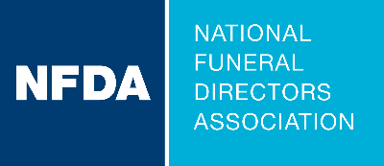

Dear [Supervisor],
I am writing to formally request approval to attend NFDA’s 2025 Leadership Conference, taking place August 3-6 in Napa, California. This annual event brings together current and emerging leaders from across funeral service to share insights, foster professional growth, and discuss strategies for leadership and innovation in the workplace.
Here are a few key reasons why attending this conference will benefit both my professional development and [enter your company name]:
- Professional Development: Here is just a sampling of the workshops and breakout sessions topics: [shorten the list to focus on topics most valuable for your firm and interests.]
- How to Do More with Less Using AI
- Leadership that Lasts
- Ask AI Anything
- Engagement Leads to Membership
- The Real Work of Leadership
- Arrangement Conference Solutions: Handling Challenging Conversations
I’m particularly interested in [fill in which one and why].
- Networking Opportunities: I will have the chance to connect with peers, potential collaborators, and thought leaders, broadening our organization’s network and exploring potential partnerships.
- Actionable Insights: I will gain new perspectives and strategies that can be implemented to improve [specific aspects of your work or organization]. I am committed to sharing the knowledge and resources I gather with our team upon my return.
Here are just a few comments from the 2024 Leadership Conference participants:
- Every year I seem to pick up on one or two new items to make us better.
- I appreciated the opportunity to talk with other state representatives and hear how they do things in their state, and took away some great ideas.
- Another great working session to empower me with tools for success!
- So good!
A detailed cost breakdown is attached which includes the registration fee, travel expenses to the conference, lodging and meals during the conference.
I am enthusiastic about the opportunity to represent [enter your company name] at the 2025 Leadership Conference and bring back valuable ideas and practices to share with the team. I am happy to discuss this request further and provide additional details as needed.
Thank you for considering my proposal, and I look forward to your response.
Sincerely,

NFDA 2025 Leadership Expense Worksheet
Attendee Name:
Expense | Information | Cost
Conference Registration | Register by JUN 1 to save! Click for rates. | $0.00
Flight |  | $0.00
Lodging | Register early to receive housing information for the Leadership Conference block. Click here for accommodation information. | $0.00
Transportation: Airport to/from hotel |  | $0.00
Transportation: Other |  | $0.00
Car Rental |  | $0.00
Food | Breakfast is included Monday - Wednesday. Estimate how much you will spend on your other meals. | $0.00
Miscellaneous | Add any other expenses you can expect with attending the conference. | $0.00
TOTAL |  | $0.00

2025 NFDA Leadership Conference Summary Report

Send a thank you note to your supervisor or leadership that includes:
- General information about the meeting
- Your appreciation for attendance

Educational Goals
The goals that I set before attending the NFDA Leadership Conference were:
  - [List goals here]

- Session Overview
My participation met all these goals and also gave me the opportunity to discuss [Enter specific valuable conversations you had] and best practices with fellow funeral service professionals.
Presenter: [Add name of presenter]
Session Name: [Add name of session]
Summary: [Summarize in your own words]

My major takeaways:
[Describe session, what you learned, and how you can apply in your role or within your organization].

Action item(s):
[Describe actions that you intend to pursue within your organization.]
Repeat this for each session attended.

Networking Opportunities
Networking event title: [Give description here] (ex. Welcome Reception, Tour, etc.)
Event summary: [Summarize in your own words]

My major takeaways:
[Describe any best practices or tips that were learned or re‐emphasized]

Action item(s):
[Describe actions that you intend to pursue with information learned]

