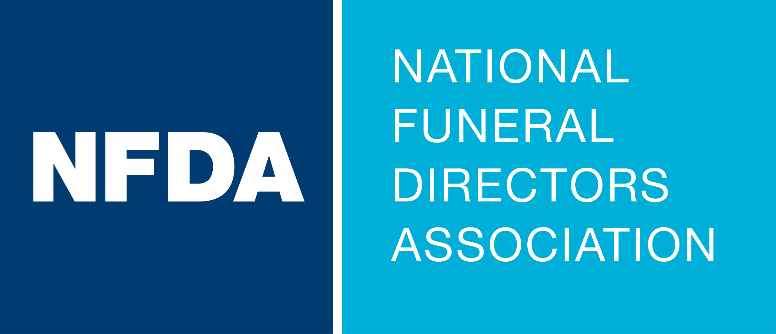

Dear [Supervisor],
I am writing to formally request approval to attend NFDA’s 2025 Leadership Conference, taking place August 3-6 in Napa, California. This annual event brings together current and emerging leaders from across funeral service to share insights, foster professional growth, and discuss strategies for leadership and innovation in the workplace.
Here are a few key reasons why attending this conference will benefit both my professional development and [enter your company name]:
- Professional Development: Here is just a sampling of the workshops and breakout sessions topics: [shorten the list to focus on topics most valuable for your firm and interests.]
- How to Do More with Less Using AI
- Leadership that Lasts
- Ask AI Anything
- Engagement Leads to Membership
- The Real Work of Leadership
- Arrangement Conference Solutions: Handling Challenging Conversations

I’m particularly interested in [fill in which one and why].
- Networking Opportunities: I will have the chance to connect with peers, potential collaborators, and thought leaders, broadening our organization’s network and exploring potential partnerships.
- Actionable Insights: I will gain new perspectives and strategies that can be implemented to improve [specific aspects of your work or organization]. I am committed to sharing the knowledge and resources I gather with our team upon my return.
Here are just a few comments from the 2024 Leadership Conference participants:
- Every year I seem to pick up on one or two new items to make us better.
- I appreciated the opportunity to talk with other state representatives and hear how they do things in their state, and took away some great ideas.
- Another great working session to empower me with tools for success!
- So good!

A detailed cost breakdown is attached which includes the registration fee, travel expenses to the conference, lodging and meals during the conference.
I am enthusiastic about the opportunity to represent [enter your company name] at the 2025 Leadership Conference and bring back valuable ideas and practices to share with the team. I am happy to discuss this request further and provide additional details as needed.
Thank you for considering my proposal, and I look forward to your response.
Sincerely,

